Jump-N-Jam
Trampoline Basketball Hoop
User Manual

Assembly, Installation, Care, Maintenance,
and User Instructions

WARNING

READ THESE MATERIALS PRIOR TO ASSEMBLING AND USING THIS TRAMPOLINE ACCESSORY.

Failure to assemble and use this Trampoline Accessory
as specified in this manual will automatically void the warranty.

Do Not return this product to the store. Instead, please visit our website at www.PropelTrampolines.com where you will find our current contact information. Our friendly customer service staff can help you with any problems or questions that may arise during the assembly, installation, use, maintenance, or obtainment of replacement parts for your Trampoline Accessory.

WARNING

When used as a trampoline accessory, this basketball hoop is to be used only with Propel brand trampolines.

Read all assembly, installation, care, maintenance, and user instructions in this manual prior to assembling and using this trampoline accessory.

Please save this manual for future reference and check our website for the latest manual revisions.

LIABILITY DISCLAIMER:
While every attempt is made to embody the highest degree of protection in all equipment, we cannot guarantee freedom from injury. The user assumes all risk of injury due to use, assembly, or transportation. All merchandise is sold on this condition, which no representative of the company can waive or change.

TABLE OF CONTENTS

BEFORE YOU BEGIN ………………………………………………………………………. 4

INSTRUCTIONAL MATERIAL AND RULES FOR USE ………………………………… 5

PARTS LIST…………………………………………………………………………………. 6

ASSEMBLY INSTRUCTIONS……………………………………………………………… 7-9

ADDITIONAL ACCESSORIES …………………………………………………………..... 10-11

LIMITED WARRANTY ……………………………………………………………………………….. 12

WARNINGS ………………………………………………………………………………… 1, 2, 4, 5

BEFORE YOU BEGIN

Thank you for purchasing a Propel Trampoline Accessory.

This trampoline accessory comes equipped with warnings and instructions for its proper assembly, care, maintenance, and use. This information must be read by all supervisors and users before any person is allowed to use it.

Follow all warnings pictured below or otherwise included in this manual. If you have any questions regarding these warnings, please contact us.

After reading this manual if you have further questions or if you would like to contact us, please visit our web site at www.PropelTrampolines.com.

Warning

1. DO NOT attempt or allow somersaults. Landing on the head or neck can cause serious injury, paralysis, or death even when landing in the middle of the jumping mat.
2. Do not allow more than one person on the trampoline or inside the trampoline enclosure. Use by more than one person at the same time can result in serious injury.
3. Use trampoline and trampoline enclosure net combination only with mature, knowledgeable supervision.
4. DO NOT hang from backboard or rim.

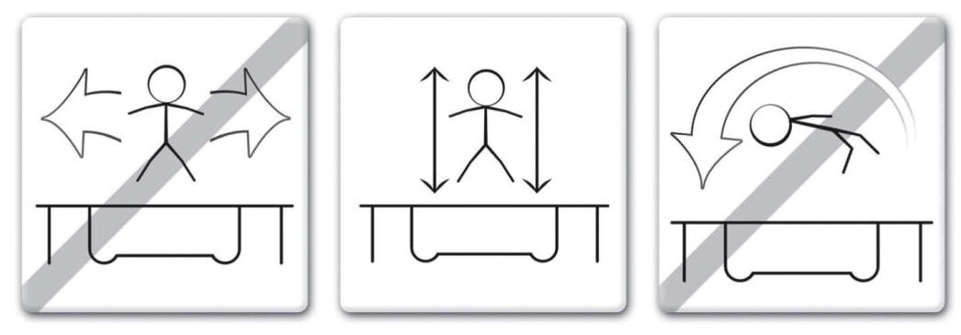

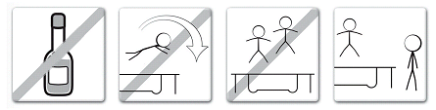

INSTRUCTIONAL MATERIAL
AND RULES FOR USE

Warning

1. DO NOT attempt or allow somersaults. Landing on the head or neck can cause serious injury, paralysis, or death, even when landing in the middle of the jumping mat.
2. Do not allow more than one person on the trampoline. Use by more than one person at the same time can result in serious injuries.
3. Use trampoline only with mature, knowledgeable supervision.
4. Trampolines over 20 in. (51 cm) tall are not recommended for use by children under 6 years of age.
5. Inspect the trampoline and trampoline enclosure net combination before each use. Make sure the barrier, enclosure support (frame), and frame padding is correctly and securely positioned. Replace any worn, defective, or missing parts.
6. Users may become entangled in or strangled by loose cords or in gaps between trampoline and enclosure net.
7. Keep enclosure net tightly fastened to the trampoline in accordance with the manufacturer’s instructions. Failure to properly assemble and maintain a tight, secure trampoline/enclosure net boundary may result in serious injury, strangulation, or death.
8. Do not attempt to jump over the barrier.
9. Do not attempt to crawl under the barrier.
10. Do not intentionally rebound off the barrier.
11. Do not hang from, kick, cut, or climb on the barrier.
12. Wear clothing free of drawstrings, hooks, loops, or anything that could get caught while using the trampoline/enclosure net and result in entanglement, strangulation, or both.
13. Do not attach anything to the barrier that is not a manufacturer approved accessory or part of the enclosure system.
14. Enter and exit the enclosure only at the enclosure door or barrier opening designated for that purpose.
15. Climb on and off the trampoline. It is a dangerous practice to jump from the trampoline to the floor or ground when dismounting. It is dangerous to jump onto the trampoline when mounting. Do not use the trampoline as a springboard to other objects.
16. Stop bounce by flexing knees as feet come in contact with the trampoline bed. Learn this skill before attempting others.
17. Learn fundamental bounces and body positions thoroughly before trying more advanced skills. A variety of trampoline activities can be carried out by performing the basic fundamentals in various series and combinations; performing one fundamental after another with or without feet bounces between them.
18. Avoid bouncing too high. Stay low until bounce control and repeated landing in the center of the trampoline can be accomplished. Control is more important than height.
19. While keeping the head erect, focus eyes on the trampoline toward the perimeter. This will help control bounce.
20. Avoid bouncing when tired. Keep turns short.
21. Properly secure the trampoline when not in use. Protect it against unauthorized use. If a trampoline ladder is used, the supervisor should remove it from the trampoline when leaving the area to prevent unsupervised access by children under 6 years of age.
22. Keep objects away which could interfere with the performer. Maintain a clear area around the trampoline.
23. Do not use the trampoline while under the influence of alcohol or drugs.
24. For additional information concerning the trampoline equipment, contact the manufacturer.
25. For information concerning skill training, contact a certified trampoline instructor.
26. Bounce only when the jumping surface is dry. Wind or air movement should be calm to gentle. The trampoline must not be used in gusty or severe winds.
27. Read all instructions before using the trampoline and trampoline enclosure net combination. Warnings and instructions for the care, maintenance, and use of this trampoline and trampoline enclosure net are included to promote safe, enjoyable use of this equipment.

PARTS LIST

Black woven Backboard x1
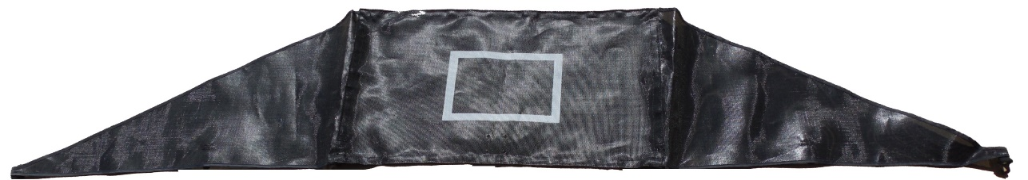

Basketball Rim x1 | Nuts and Bolts x2 each
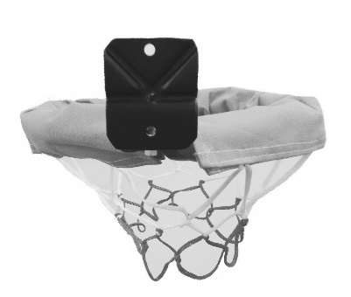 | 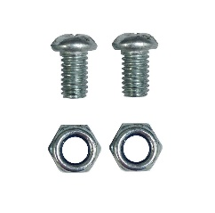
Support poles x2 long, x2 short (A) x2 Short (B) | L-Shaped Basketball post x1
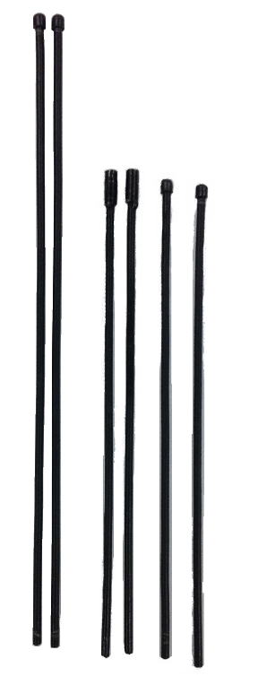  (A) (B) | 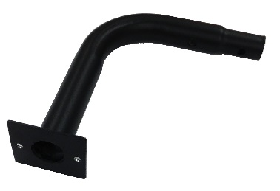

ASSEMBLY INSTRUCTIONS

Read and understand all assembly instructions before beginning the assembly process.

To assemble your Jump-N-Jam basketball hoop on your Propel Trampoline; please follow the steps below:

Step 1- Lay the black woven backboard face down. Insert the support poles. See diagram.
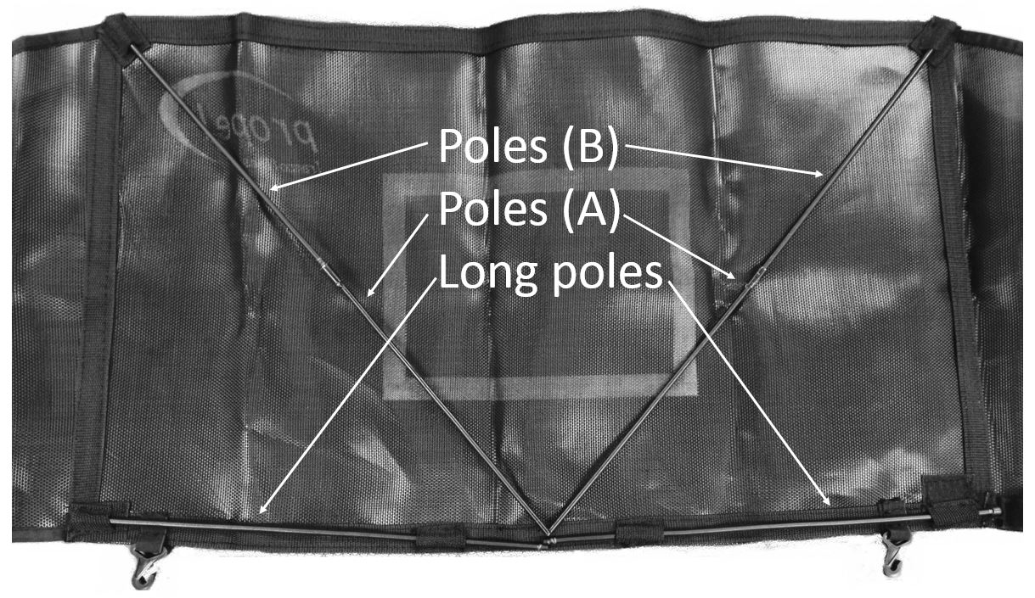
Step 2- Place the basketball rim in the correct position and insert the two bolts into the two holes in the basketball rim. See diagram.
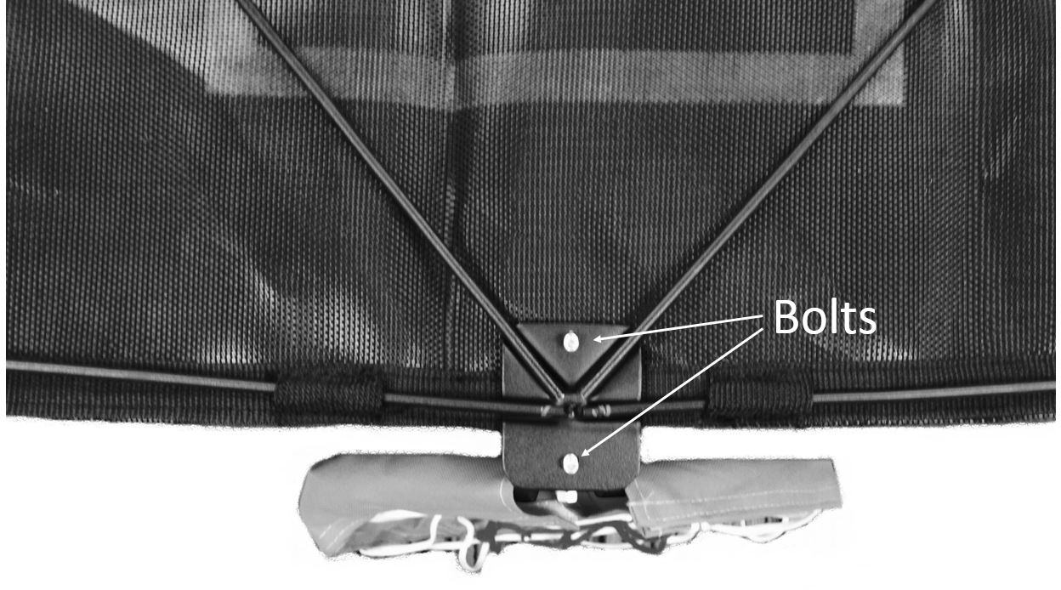
Step 3- Place the basketball post over the current assembly, then tighten the nuts and bolts.
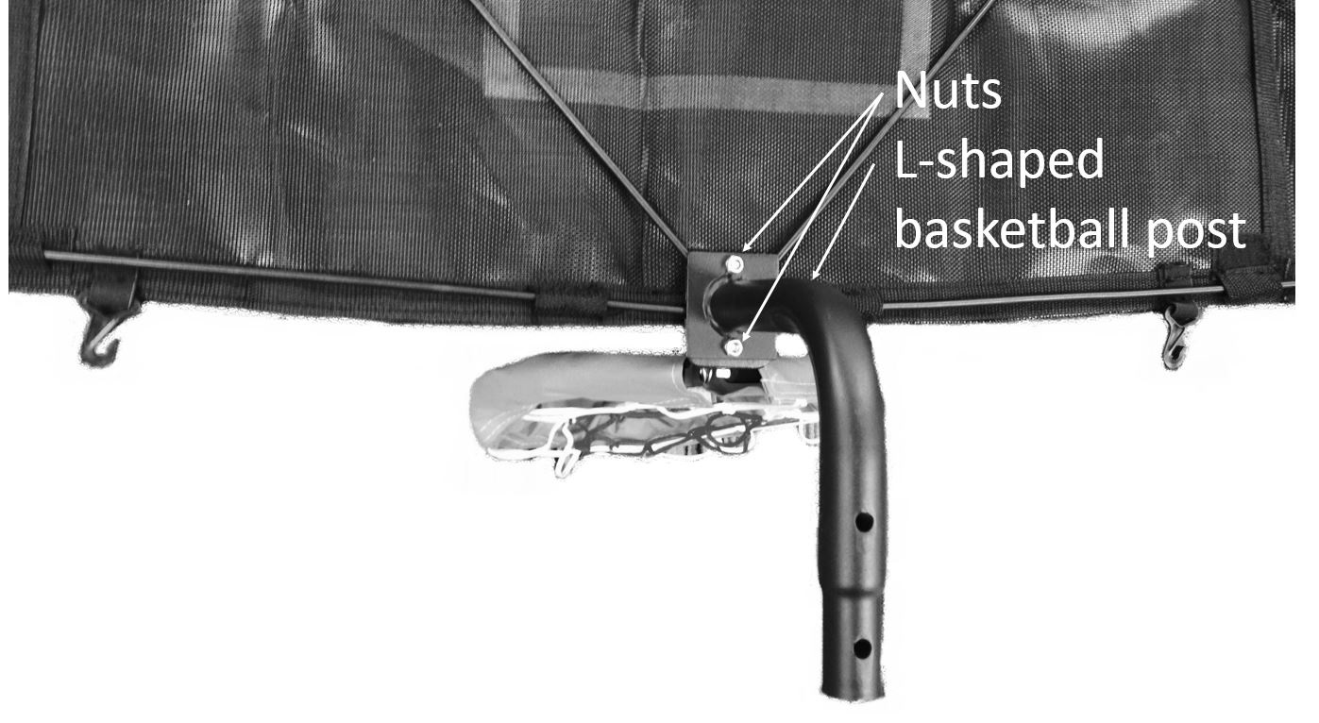

Step 4- Secure the Velcro in the bottom corner of the backboard.
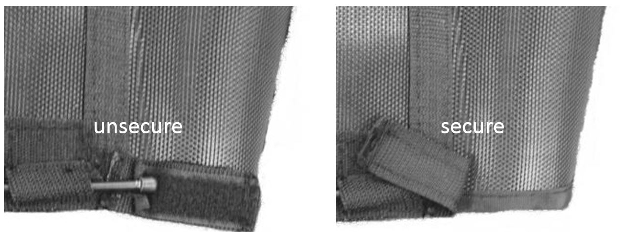

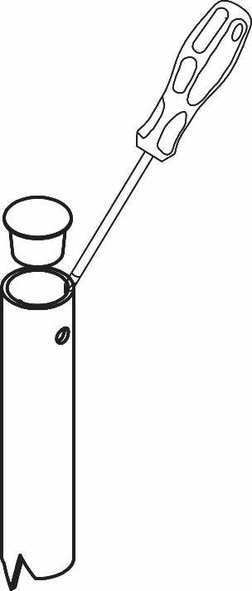
Step 5- Select the trampoline enclosure pole on which you wish to install the Jump-N-Jam. Using a flathead screwdriver or a similar tool, pry the black top cap off the enclosure pole, as shown in figure to the right.

Step 6- Remove the eyebolt that attaches the enclosure bungee to the enclosure pole.

Step 7- Insert the Jump-N-Jam into the top of the enclosure pole and rotate it so that the hoop faces the center of your trampoline, as shown in figure 1 below. Reattach the enclosure bungee eyebolt, thus holding the Jump-N-Jam in place. Note: When the eyebolt and bungee is replaced, your trampoline enclosure will once again be assembled properly.
Figure 1

Note: The enclosure net should still be attached to the bungee eyebolt system. Thus, when the Jump N Jam is completely assembled your enclosure net should still remain fully assembled as well.
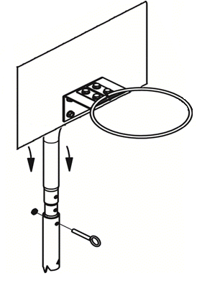

Step 8- Attach the plastic hooks on the bottom of the black woven backboard to the net/enclosure below each hook. This helps stabilize the Jump-N-Jam.

This completes the assembly and installation of your Jump-N-Jam Basketball Hoop.

ADDITIONAL ACCESSORIES
Basketball Hoop x1

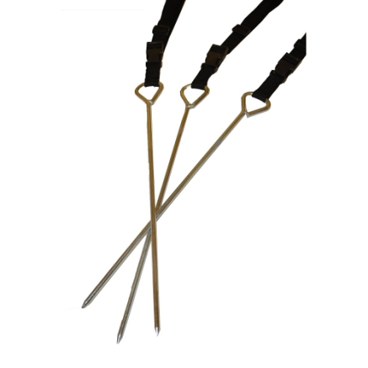
Anchor Kit-
Do you like to see your trampoline fly? Neither do we, that's why we carry the "StormRider" trampoline anchor kit. Our Stormrider Anchor kit includes three galvanized steel stakes which connect to your trampoline via high-strength straps. When used correctly, an Anchor Kit can help reduce the risk of costly wind damage to your trampoline.

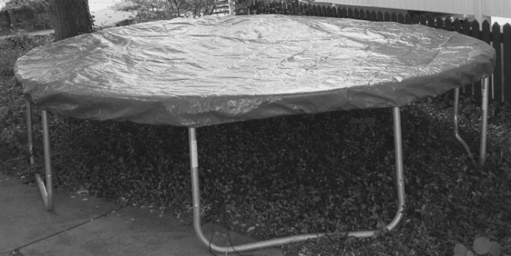
Weather Cover-
From the scorching summer heat to the freezing winter snow and rain the Propel Trampoline’s Weather Cover can help protect your trampoline. Made from a weather resistant woven poly material it can be used in all 4 seasons; making it the perfect product to protect and help extend the life of
your trampoline.
Note: Weather cover is not designed to support snow loads.

Ladder-
The Propel Trampoline’s Ladder provides a step-by-step method for accessing your trampoline. A trampoline ladder can help prevent injuries sustained by jumping on or off the trampoline.

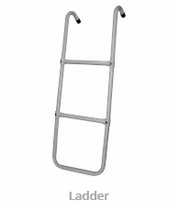
Note: Ladder should be detached from trampoline when unauthorized use of trampoline is not permitted. Ladder is not to be used by children under 6 years of age.

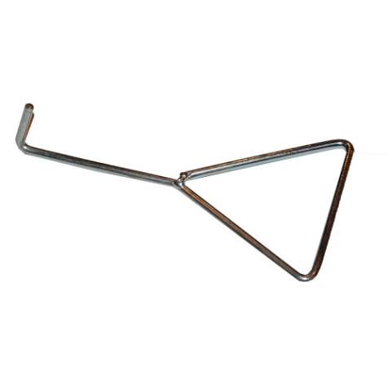
Spring Puller-
Need an extra "hand" in assembling your trampoline? Try a Spring Puller! This useful tool can help make attaching the springs a breeze.

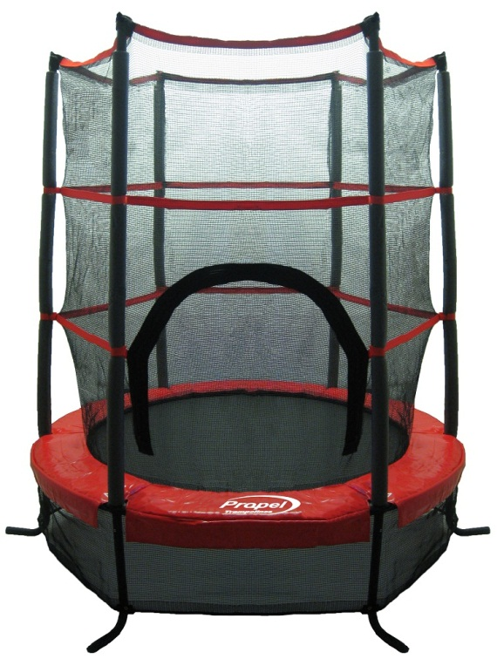
Preschool Trampoline-
The Propel Preschooler trampoline is a safe and fun trampoline for your little ones. The Preschooler trampoline includes a soft yet durable safety enclosure attached directly to the jumping mat, with thick padded poles to prevent your child from falling off. A base net prevents toys, children and pets from accessing under the jumper. Instead of hard metal springs, it incorporates 30 heavy duty bungees to provide a great bounce while eliminating the dangers of conventional springs. The healthy fun of the Propel Preschooler Trampoline can be used both indoors and outdoors so your children can jump anytime. Bring it along to the park, or into the play room when the weather turns sour. Wherever you are, the Propel Preschooler trampoline can be too!

For more information or to order any of these accessories, please visit our website at www.PropelTrampolines.com.

LIMITED WARRANTY

PROPEL warrants its trampoline products to be free from defects in material and workmanship under normal use and service conditions. The galvanized steel trampoline frame and springs are warranted for one (1) year from the date of purchase. All other parts are warranted for ninety (90) days from the date of purchase.

All warranty coverage extends only to the original retail purchaser from the original date of purchase. Our obligation under this warranty is limited to replacing or repairing the product at our discretion. All products for which a warranty claim is made must be received by us through our Customer Service department which can be contacted at: cs@propeltrampolines.com (with a picture of the receipt and any damage to the product) or by calling 1-855-776-7351. Freight must be prepaid and accompanied by proof of purchase. All returns must be pre-authorized. This Warranty does not extend to any product, or damage to a product that is caused by or attributable to freight damage, abuse, misuse, improper or abnormal usage, act of God, storm damage, installation or use of accessories, and to products used for commercial or rental purposes. No other warranty expressed or implied beyond that specifically set forth above is authorized.

Propel Trampolines is not responsible or liable for indirect, special, or consequential damages arising out of, or in connection with the use or performance of this product. Propel is not responsible for other damages with respect to any economic loss, loss of property, loss of revenue or profits, loss of enjoyment or use, cost of removal or installation, and any other consequential damages. In the United States of America some states do not allow the exclusion or limitation of incidental or consequential damages. Accordingly, the above limitation may not apply to you.

The warranty extended hereunder is in lieu of all other warranties, and any implied warranty of merchantability or fitness for a particular purpose is limited in its scope and duration to the terms set forth herein. In the United States of America some states do not allow limitations on how long an implied warranty lasts. Accordingly, the above limitation may not apply to you.

This warranty gives you specific legal rights. You may also have other rights which vary from state to state in the United States of America.

V2.0 - © 2016 Propel Trampolines - Printed in China

